

VISHWAKARMA INSTITUTE OF INFORMATION TECHNOLOGY, PUNE

**Mini Project Report – Project Work- 1**

On

**Hotel Search Website**

**Under the Guidance of**

**Professor: Mrs. F. M. Inamdar**

SUBMITTED BY

|  |  |  |
| --- | --- | --- |
| GR.NO | ROLL.NO | NAME |
| 22010910 | 332002 | Niraj Amrutkar |
| 22010070 | 332010 | Chirag Chawade |
| 22010826 | 332011 | Harsh Chawla |
| 22010416 | 332025 | Chetan Ingle |

**Index**

|  |  |  |
| --- | --- | --- |
| Sr. No. | Content | Page No. |
| 1 | Problem Statement: | 3 |
| 2 | Objective/Scope: | 3 |
| 3 | Functional and non-functional requirements: | 3 |
| 4 | System Architecture: | 4 |
| 5 | Webpage Output: | 6 |

**Hotel Management System**

**Problem Statement:**

The Online Hotel Searching Website is a project implemented for providing people all Over the world with an easy and fast way to search and compare hotels online in a particular area.

The Online Hotel Searching website is an easy-to-use application. Everyone who knows how to use a Web browser can easily carry out searching, comparing, adding reviews of the hotels by following its simple and clear GUI (Graphical user interface) design.

**Objective/Scope:**

This project is a Web-based application that provides a user-friendly and simple interface to let users easily search for hotels in a particular area, watch its reviews and perform booking activities via Internet.

The project uses a regular Web browser with HTML (Hyper Text Markup Language) as the basic interface language. Users can perform various activities like searching hotels in their area, view/add reviews and contact the hotel for booking via the Internet browser. The administrations also can view all users' files and maintain the Web site on it. The Web pages are written in JavaScript and stored in Apache server. All the data is stored in a MySQL database and accessed by Node JS.

The Online Hotel Searching System is a very easy-to-use Web-based application. Everyone who knows how to use a Web browser can book rooms on specific date and finish the basic payment process online. Users can login into their account and continue with the hotel searching activities onto the website.

**Functional and non-functional requirements:**

The Online Search website offers the following functionality:

1. Users can register at website and then they can view or modify the personal profile.

2. Users can search for available hotels in a particular area on any specific date.

3. Users can view all the reviews and images of the Hotels.

4.Users can add all the reviews of the Hotels.

5. Administrators can add any specific Hotel in the list.

6. Administrators can modify the details of static pages including room information, about us information, contact us information, customer service Q&A details, local travel and shipping guide, and privacy policy after login.

7. Besides the basic booking relative functions, this simulated website contains basic room type’s introduction, contacting information, customer service Q&A, local travel and shipping guide, and privacy policy

Non-functional requirements:

**1.Speed** – The system functions normally without lagging.

**2.Availability** – The website must be available 24 x 7 for the user.

**3.Reliability** – The system is almost independent and does not depend on any other technical system for its functioning.

**4.Usability** – System is very user friendly and user can easily interact with it.

Dependability: As it is web-based, it can run on almost all OS and there are no hardware constraints as such.

**System Architecture:**

The Online Hotel Booking System implements a Web system that provides an environment for users to book hotel rooms online. The system is a **2-tier-distributed architecture** that displays the user interface to a Web browser using Node JS.

**Software Interfaces:**

• Internet browsers.

• Operating system: Windows 98/2000/XP, or Unix/Linux

• Database: **MySQL**

• I Language: **HTML / JavaScript / Bootstrap / Node JS.**

• Connect Protocol: Hypertext Transfer Protocol and Hypertext Transfer Protocol by SSL

The Web application executes a user command:

• User types a URL in Web browser.

• Request is transmitted to Web server via HTTP protocol.

• User's Web browser displays HTML page.

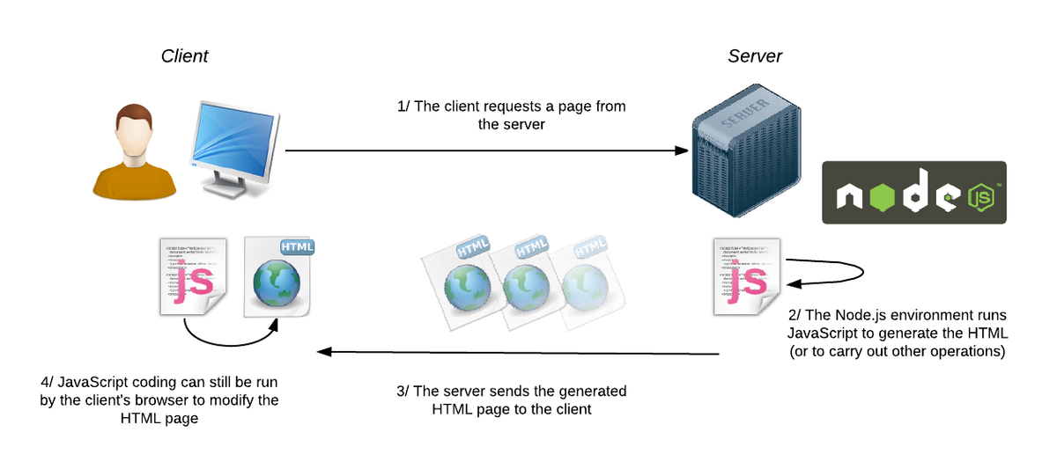

The components used to build Online Hotel Searching System were chosen with the following criteria:

(I) the components should be shareware, i.e., available freely for all users, (II) they do not depend on a specific operating system and hence are easily portable across systems, (III) database server's flexibility, so that new and different versions of the server can be plugged in easily.

The user interface components are built by using HTML 6.0 forms, HTTP, frames and JavaScript. The application is implemented using Hypertext Pre-processor (Node JS). Node JS is mainly focused on server-side scripting, so it allows functionalities such as collect form data, generate dynamic page content, or send and receive cookies. Node JS can be used on all major operating systems and it is not limited to output HTML. One of the strongest and most significant features in PHP is its support for a wide range of databases.

The database availability to online Hotel Booking system is MySQL. MySQL is a real multi-user database and free. Also, because of its consistent fast performance, high reliability and ease of use, it has become the world's most popular open-source database ranging from large corporations to specialized embedded applications on every continent in the world. It runs on more than 20 platforms including Linux, Windows, OS/X, HP-UX, AIX, Netware, giving flexibility and is the reason of using MySQL.

**Webpage Output:**

